***ELEC 300 — Linear Circuits: II — Spring 2018*** ***Name ___________________***



***Assignment 05 — due Monday, 19 Feb 2018, in class*** ***Std #____________________***

**Problem 1**

The bandpass filter was originally designed for *Q* > 20 with *R* = 5 k , *L* = 2 H and *C* = 50 pF. Now the filter is loaded with *RL*, but the quality factor is not to drop below 10. What is the smallest possible value of the load resistor *RL*, given the transfer function

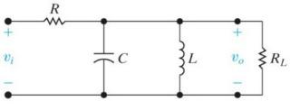

*H* ( ) = *vo* ( ) = *vi* ( )

|  |  |  |  |  |  |  |  |  |
| --- | --- | --- | --- | --- | --- | --- | --- | --- |
|  |  |  | *j L R* | | | |  |  |
|  | æ | 1 |  | 1 | ö |  | 2 |  |
|  | ç |  | ÷ |  |  |
|  |  |  | + |  | ÷ |  | ) *LC* |  |
| 1+ *j L*ç | |  |  | ÷ | +( *j* |  |
|  | **ç** | *R* |  |  |  |  |  |
|  | è |  | *RL* ø | |  |  |  |



**Problem 2**

Use a 500 nF capacitor to design the bandreject filter. The design specifications are *f*0 = 5 kHz and *Q* = 20.

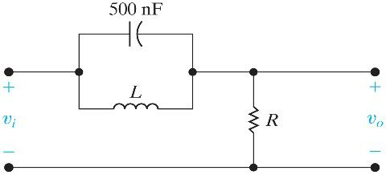

**Problem 3**

1. Obtain the transfer function *H*(*s*) of the active filter.
2. What kind of a filter is it?
3. Calculate the corner or resonance frequency.

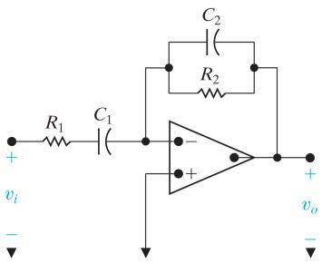

**Problem 4**

1. Find the transfer function of this filter.
2. Determine whether it is a lowpass or a highpass filter.
3. What is the amplification for frequencies that pass the filter?

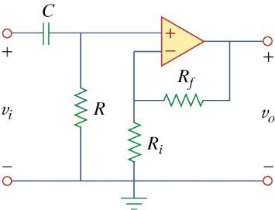

Page 1 of 2

**Problem 5**

Design a circuit to realize the following transfer function using only 10-k resistors, positive value capacitors, and OP AMPs.

|  |  |  |
| --- | --- | --- |
| *H* ( *s*) | 1000 *s* |  |
| *s* 1000 *s* 4000 |  |

**Problem 6**

The bandpass filter is designed for 100 krad/s and a bandwidth of 12.5 krad/s. Scale the filter

to get a center frequency of 25 kHz using a 25 H inductor. Determine the values of the resistor and the capacitor of the scaled filter.

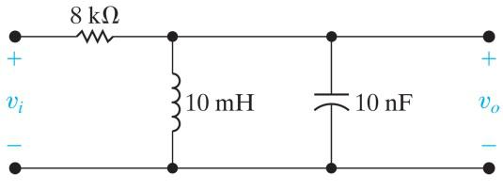

Page 2 of 2